# Summarizing Columns

Referenced from lesson [Histograms](https://www.bootstrapworld.org/materials/spring2021/en-us/courses/data-science/lessons/histograms/index.shtml) (Spring, 2021)

| name | species | age | pounds |
| --- | --- | --- | --- |
| "Sasha" | "cat" | 1 | 6.5 |
| "Boo-boo" | "dog" | 11 | 12.3 |
| "Felix" | "cat" | 16 | 9.2 |
| "Nori" | "dog" | 6 | 35.3 |
| "Wade" | "cat" | 1 | 3.2 |
| "Nibblet" | "rabbit" | 6 | 4.3 |
| "Maple" | "dog" | 3 | 51.6 |

| 1 | How many cats are there in the table above? |  |
| --- | --- | --- |
| 2 | How many dogs are there? |  |
| 3 | How many animals weigh between 0-20 pounds? |  |
| 4 | How many animals weigh between 20-40 pounds? |  |
| 5 | Are there more animals weighing 40-60 than 60-140 pounds? |  |

The charts below are both based on this table. What is similar about them? What is different?

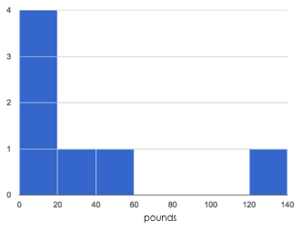

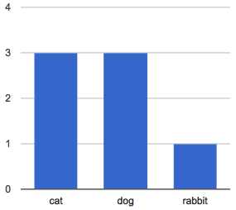

| **Similarities** | **Differences** |
| --- | --- |
|  |  |
|  |  |
|  |  |

*These materials were developed partly through support of the National Science Foundation, (awards 1042210, 1535276, 1648684, and 1738598).  Bootstrap:Data Science by the* [*Bootstrap Community*](https://bootstrapworld.org/community/index.shtml) *is licensed under a* [*Creative Commons 4.0 Unported License*](https://creativecommons.org/licenses/by-nc-nd/4.0/)*. This license does not grant permission to run training or professional development. Offering training or professional development with materials substantially derived from Bootstrap must be approved in writing by a Bootstrap Director. Permissions beyond the scope of this license, such as to run training, may be available by contacting* [*contact@BootstrapWorld.org*](https://www.bootstrapworld.org/materials/spring2021/en-us/courses/data-science/lessons/histograms/pages/mailto:contact@BootstrapWorld.org)*.*

Last updated 2021-12-08 12:31:27 -0500